Test Case: tc001_SPX_Dev5_Crear_Requisicion_Spot_Tipo_Cobro_CC
Step 1 - Enter username and password and click to button Enter : Credentials Entered
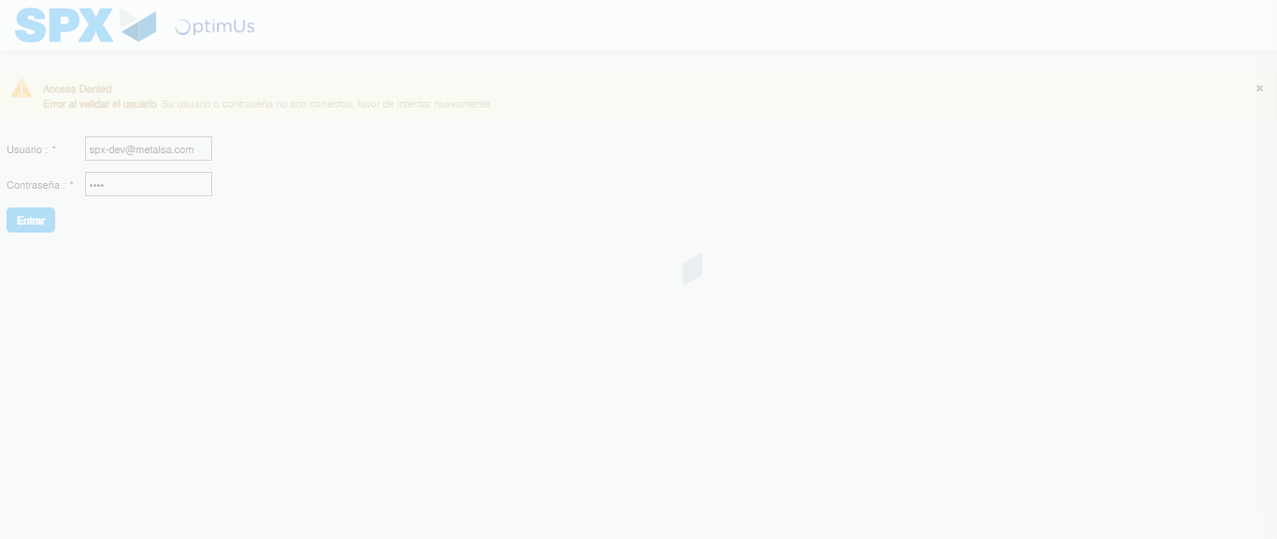Image file-name: QC_Testing-tc001_SPX_Dev5_Crear_Requisicion_Spot_Tipo_Cobro_CC-1790177318468

Step 2 - Select to UEN and Access to Spot Buy Requisitions : UEN Correctly selected and Correct access
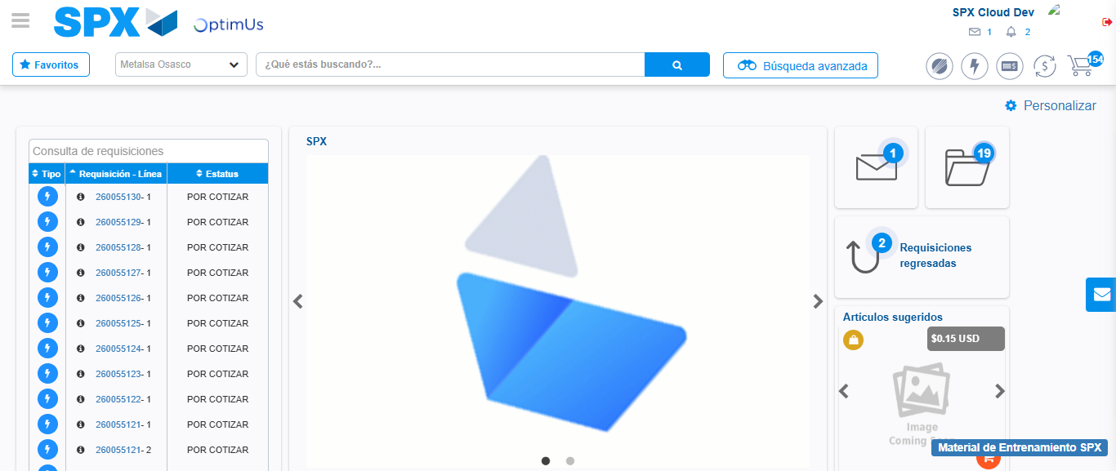Image file-name: QC_Testing-tc001_SPX_Dev5_Crear_Requisicion_Spot_Tipo_Cobro_CC-1790177342763

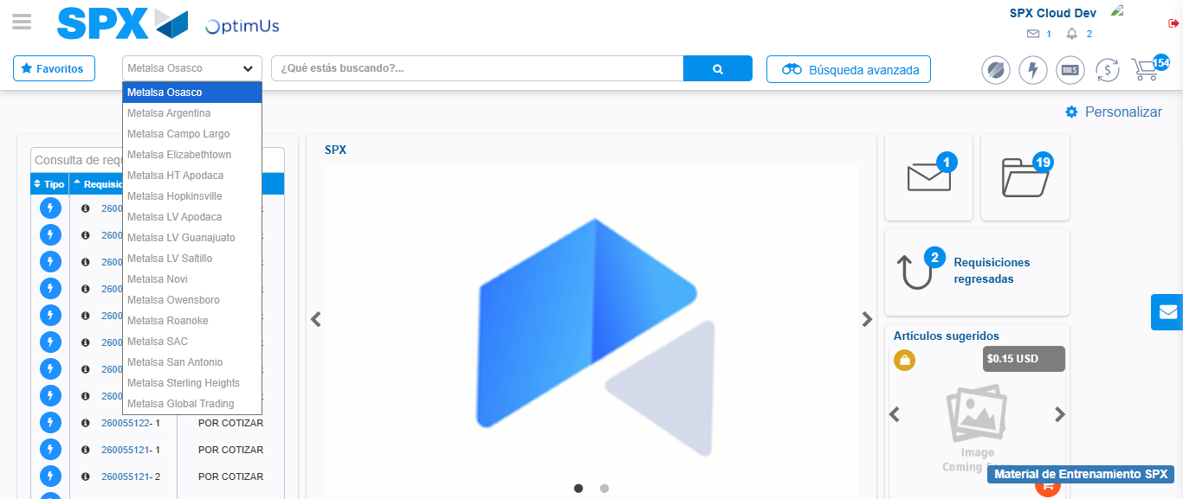Image file-name: QC_Testing-tc001_SPX_Dev5_Crear_Requisicion_Spot_Tipo_Cobro_CC-1790177343472

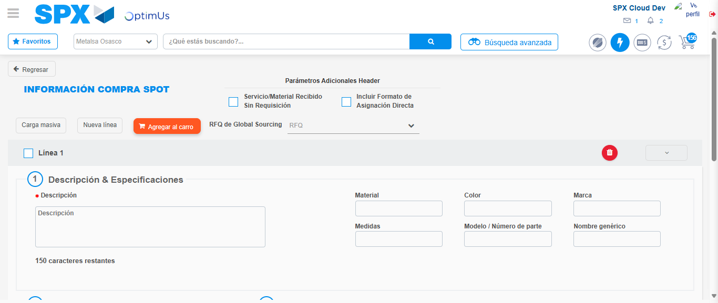Image file-name: QC_Testing-tc001_SPX_Dev5_Crear_Requisicion_Spot_Tipo_Cobro_CC-1790177354865

Step 3 - Data Capture Spot Buy Requisition : Data captured correctly
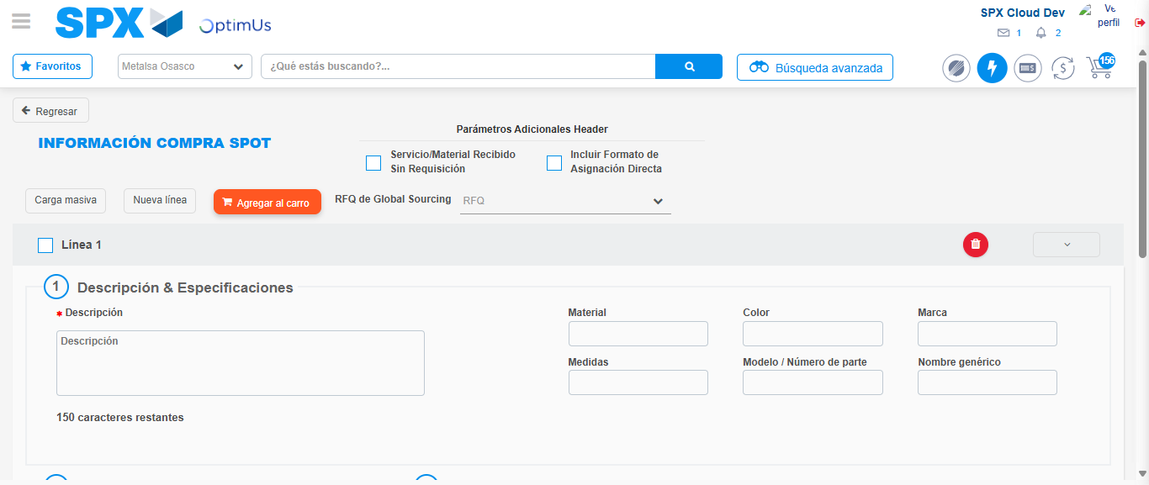Image file-name: QC_Testing-tc001_SPX_Dev5_Crear_Requisicion_Spot_Tipo_Cobro_CC-1790177355138

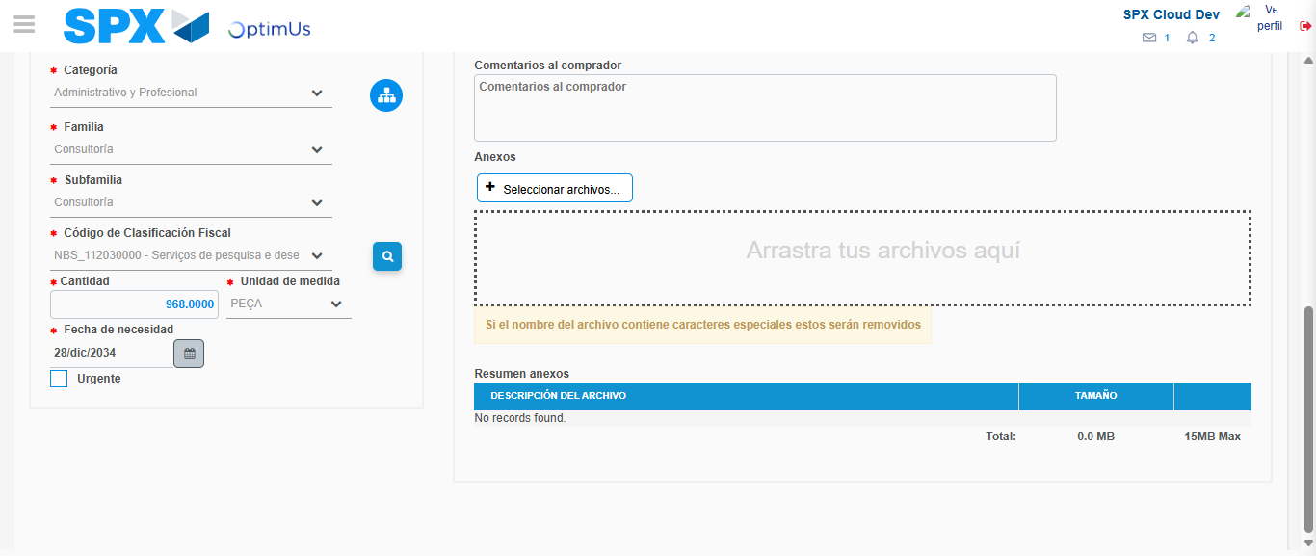Image file-name: QC_Testing-tc001_SPX_Dev5_Crear_Requisicion_Spot_Tipo_Cobro_CC-1790177374851

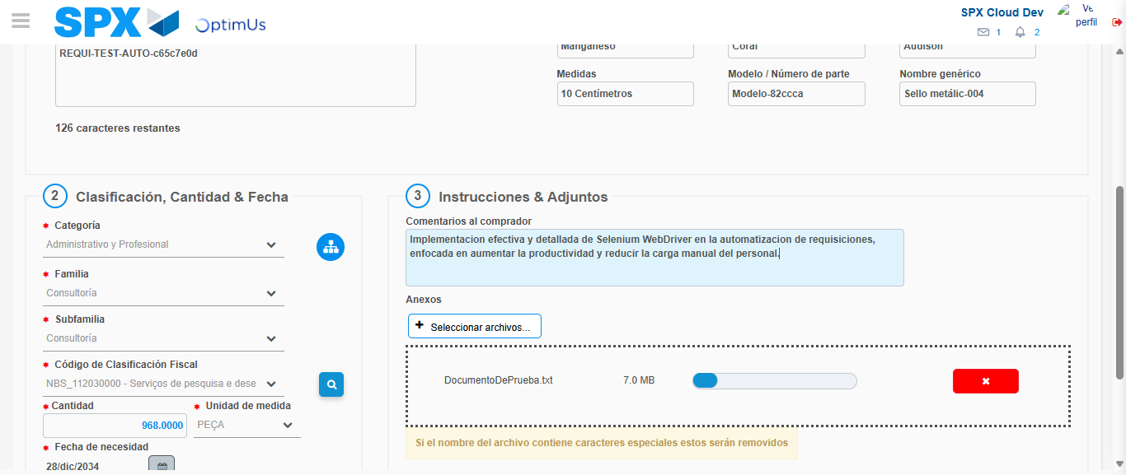Image file-name: QC_Testing-tc001_SPX_Dev5_Crear_Requisicion_Spot_Tipo_Cobro_CC-1790177375900

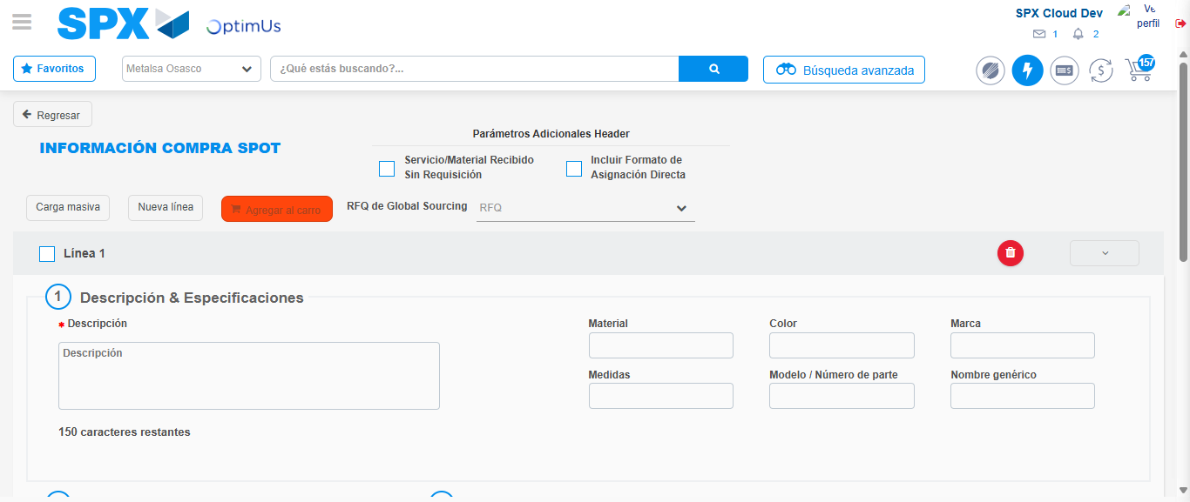Image file-name: QC_Testing-tc001_SPX_Dev5_Crear_Requisicion_Spot_Tipo_Cobro_CC-1790177378561

Step 7 - Return to Main Page SPX : Return to Main Page SPX
Image file-name: QC_Testing-tc001_SPX_Dev5_Crear_Requisicion_Spot_Tipo_Cobro_CC-1790177342763

Image file-name: QC_Testing-tc001_SPX_Dev5_Crear_Requisicion_Spot_Tipo_Cobro_CC-1790177343472

Image file-name: QC_Testing-tc001_SPX_Dev5_Crear_Requisicion_Spot_Tipo_Cobro_CC-1790177354865

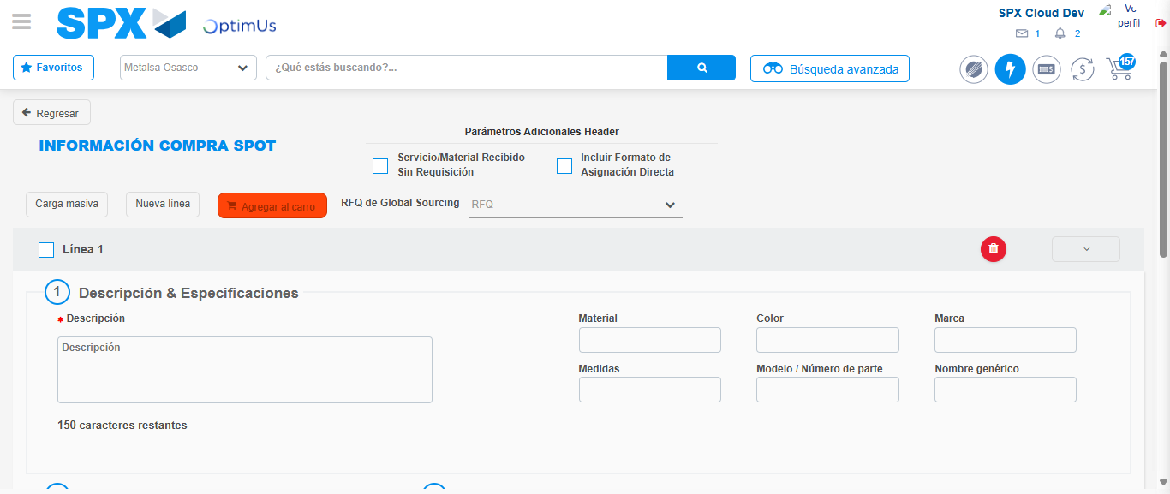Image file-name: QC_Testing-tc001_SPX_Dev5_Crear_Requisicion_Spot_Tipo_Cobro_CC-1790177380822

Image file-name: QC_Testing-tc001_SPX_Dev5_Crear_Requisicion_Spot_Tipo_Cobro_CC-1790177381008

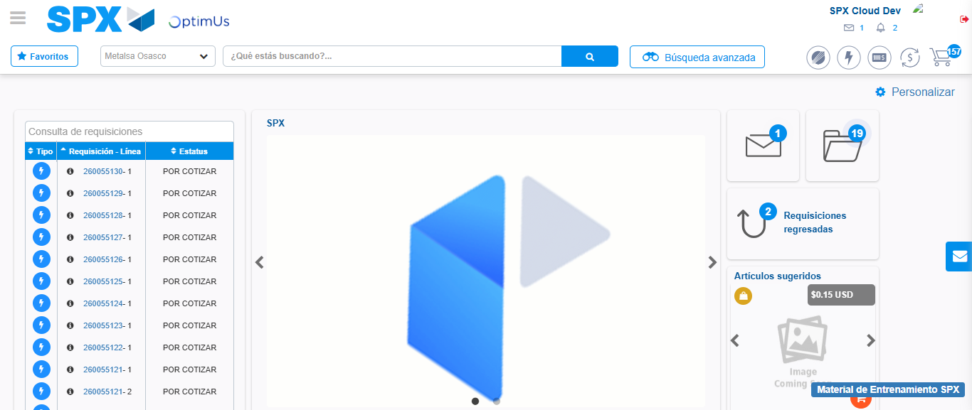Image file-name: QC_Testing-tc001_SPX_Dev5_Crear_Requisicion_Spot_Tipo_Cobro_CC-1790177402407

Step 8 - Log Out : Log Out SPX
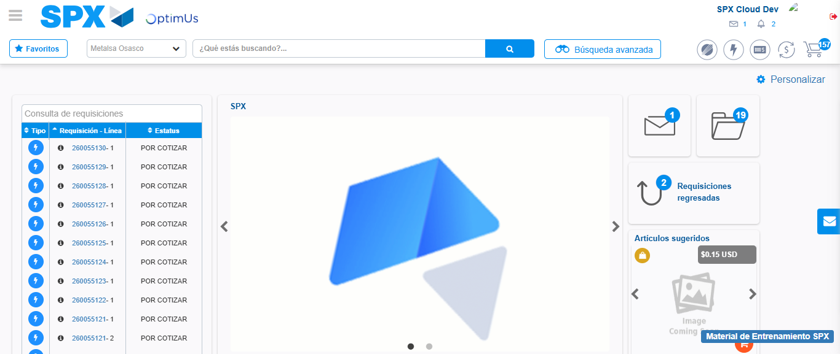Image file-name: QC_Testing-tc001_SPX_Dev5_Crear_Requisicion_Spot_Tipo_Cobro_CC-1790177402757

